This is the main login screen and the application is “gateg1”.

Type “gateg1” and press <Enter>.

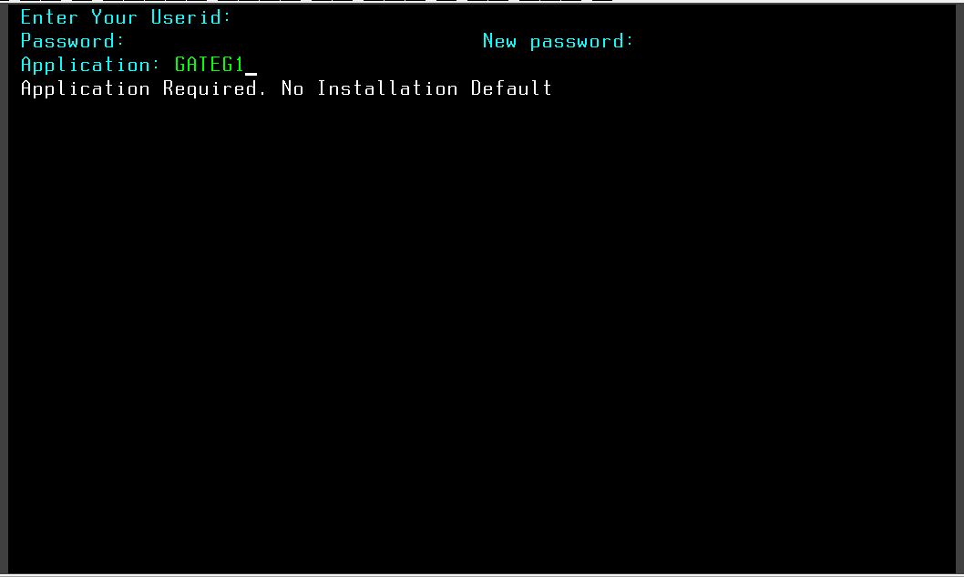

Enter 7 letters User id followed by Password and press <Enter>.

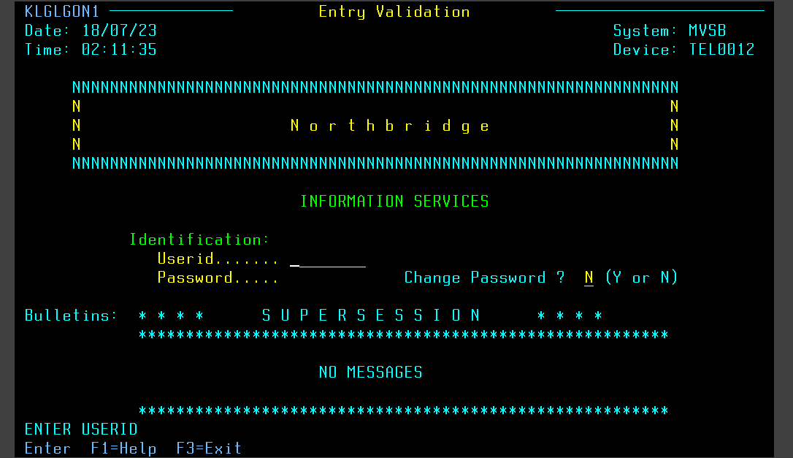

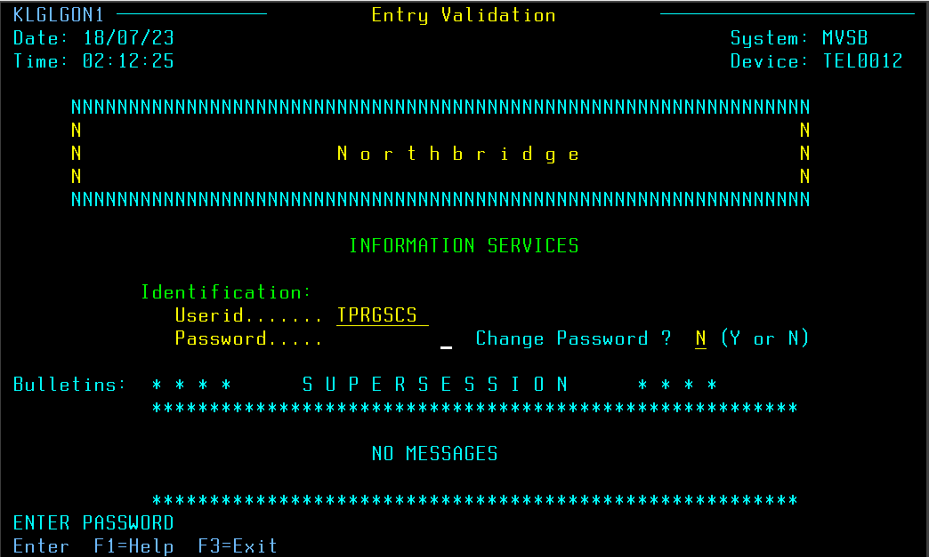

Then you will navigate to next screen “Main Menu”.

To select <SYSTEM TEST> type “S” in front of < SYSTEM TEST> and press <Enter>.

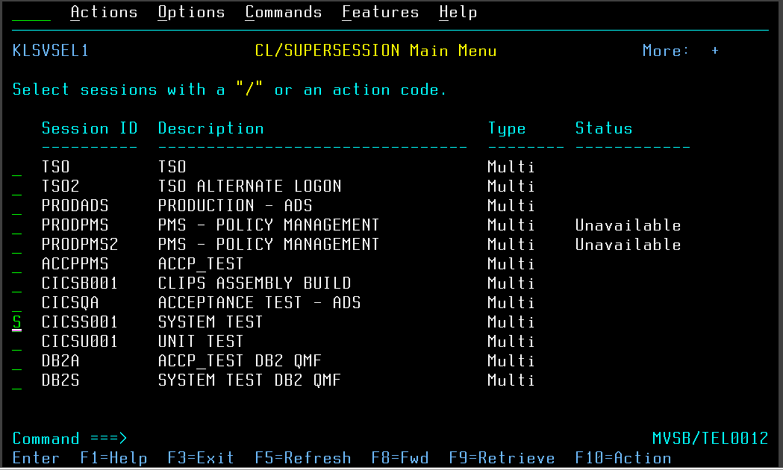

Press ‘8’ at <TESTFILE ID> field and press <Enter>.

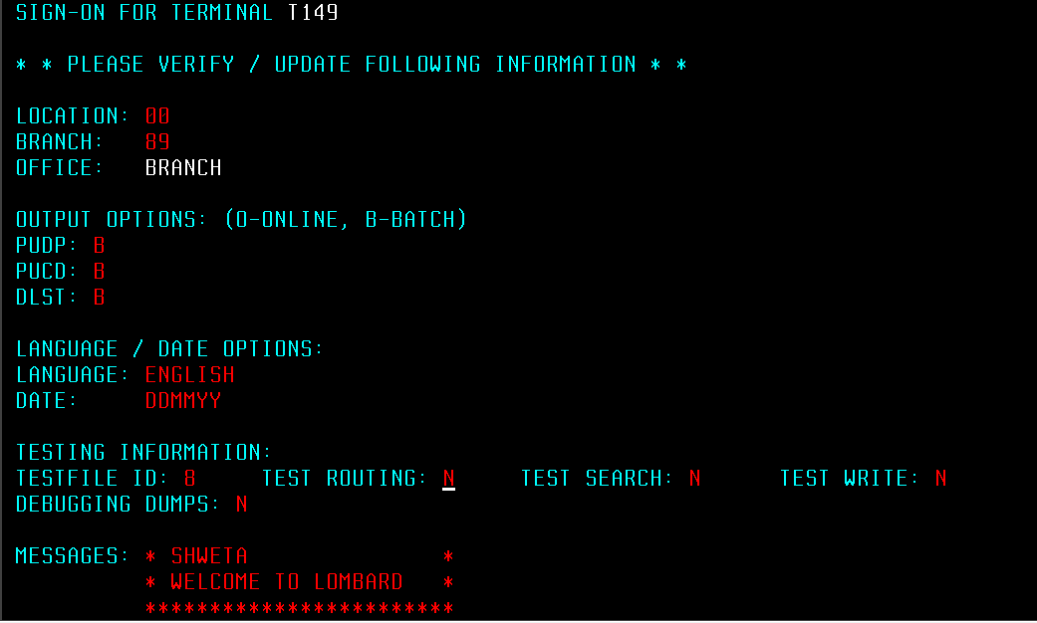

To clear the screen press <Pause/Break> from Keyboard.

From Laptop – select <Show keypad> and select <Clear> to clear the screen.

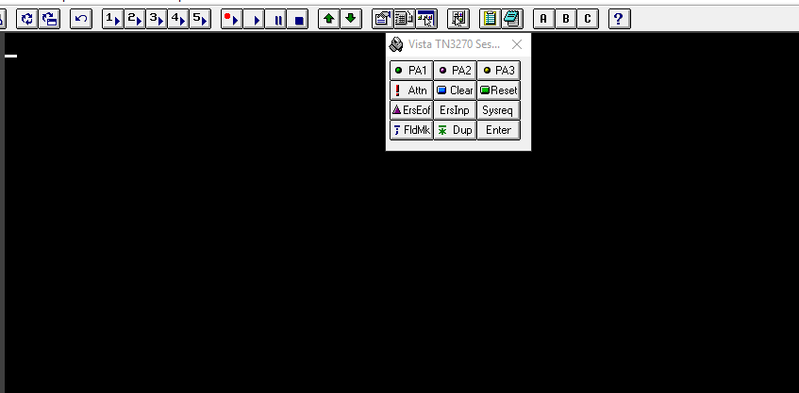

Type <PIBC> Space < > Policy number up to 7th place <7654321> and press <Enter>.

Policy number consist of one alphabet ’P’ followed by eight-digit number.

If the policy number is P87654321, then enter 7654321 as policy number in PMS.

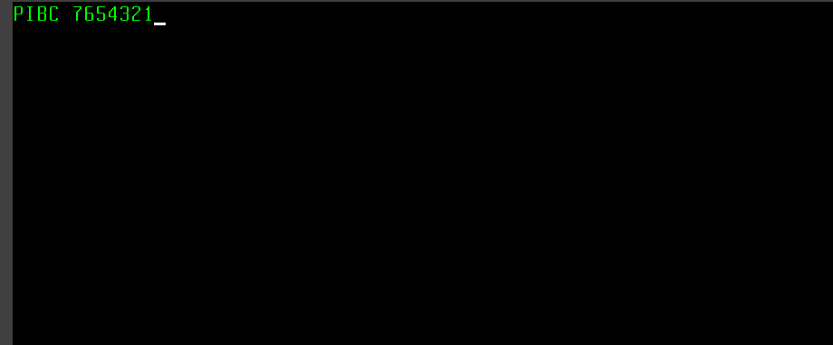

PIBC screen contains basic contract information about Insured and policy such as Insured name, place, address, postal code, policy effective and expiry date, agent number, seven digit customer number etc.

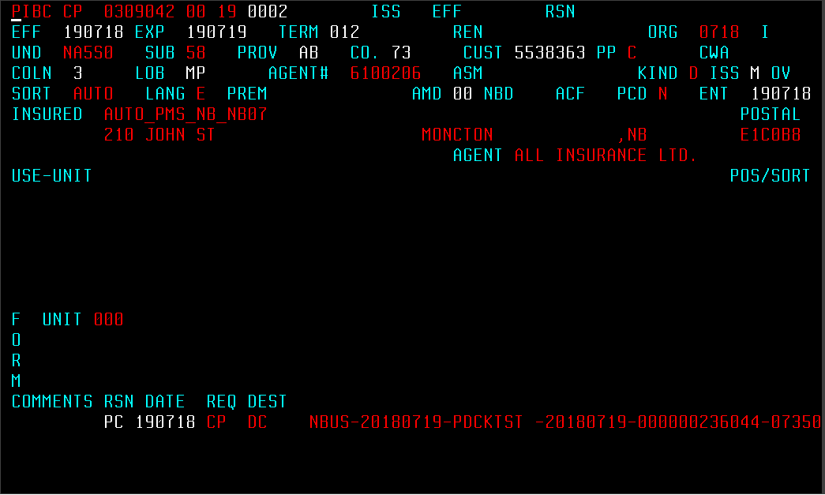

PISA screen contains information of coverages those are selected in Duck Creek. Basically three lines of business, property, liability and automobiles.

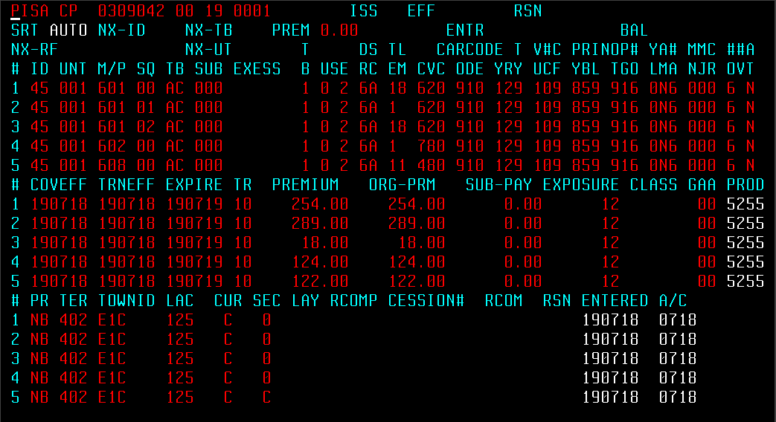

PUIT screen contains information of vehicle and the driver associated to it.

Such as vehicle year, vehicle id, type (private or commercial), driver name, license number etc.

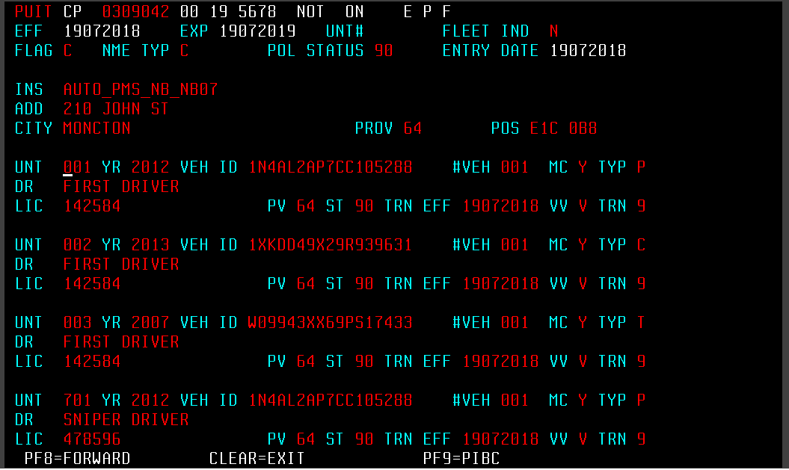

**PISA screen**

**Some important fields are mentioned below for Auto**

**SYMBOL** CBC Business Choice, Manufacturer’s Choice, Farm Choice,

Transportation, Builders’ Choice

CP Duck Creek Policies

**MODULE** 2-digit number. This number shows the number of times policy renewed or reissued.

For New Business Module is 00

For first renew/ reissue Module will be 01

ISS

EFF

ID Identification number. 45 is default.

UNIT 3-digit number. 001 for first vehicle, 002 for second vehicle and

so on

M/P Major Peril. It indicate the type of policy coverage

SQ Sequence number. Each coverage has a sequence

*On combining both M/P and SQ it forms a coverage code and thus each Policy coverage has a unique Coverage Code.

USE Vehicle use or Vehicle Class

D 2-digit number mapped from Duck-Creek

R

S Sub Class. It is represented by an alphabet associated to Vehicle

C Class depending on the type of vehicle is used. Example: A, G etc.

L Limits and Deductibles. Refer to CBC auto sheet for Auto.  
M

CV For each coverage there is a coverage code if limits and deductibles are associated to it. Refer to CBC auto sheet for Auto.

CODE First four digit of car code is populated in PMS.

For trailer- it trailer price is 1000 then Car Code for Trailer will populated as T001. i.e. T followed by 1st, 2nd and 3rd position number of trailer cost after dividing it by 1000.

YR Vehicle Year. Last two digit of vehicle manufacture year.

Example: if vehicle manufacture year is 2001 then it maps to PMS as 01.

T Type of vehicle

Y PPV - 9 Default

CA - Light - 4

Heavy - 6

Tractor - 8

Trailer –

V Vehicle Use. This field is only for Private Vehicle

U PPV- 1 (Pleasure)

2 (Commute)

3 (Business)

# Number of Claims. It shows the number of chargeable claims on

C a vehicle. Example: 0, 1, 2,…, 9 for nine or more claims

C Claim free years of Vehicle

F

YBL principle driver’s year of birth and year licensed

TGO Driver’s training, gender and number of operators

M Minor conviction

N

M Major Conviction

J

C Critical Conviction

R

*Above three are the type of convictions. In PMS screen number of convictions will mapped in the respective type of conviction field.

COVEFF Coverage Effective Date. Coverage will be effective or applicable

on the policy from this day.

TRNEFF Transaction Effective Date. On this day the transaction is going

to effect on the respective coverage.

EXPIRE Expiry date. On this day the coverage is going to expire.

TR Transaction. It populates the type of transaction done on the

policy coverage.

AV – addition of vehicle

DC – deletion of vehicle

PREMIUM

ORG-PRM

SUB-PAY

EXPOSURE For auto it shows the number of months

CLASS

GAA

PROD

PR Provience code

AB - Alberta

NB - New Brunswick

NL – Newfoundland and

NS – Nova Scotia

ON - Ontario

PE -

PQ - Quebec

TER

TOWNID

LAC

CUR Currency

RSN Reason code. It populates the type of transaction done on the

Coverage.

ENTERED

A/C

**PUIT SCREEN**

INS Insured name

ADD Address of Insured

CITY City

PROV Province Code

POS Postal Code

UNIT Unit Number

YR Vehicle Manufactured Year

VEH ID Vehicle Identity Number (VIN)

#VEH Number of Vehicle. It is the sequence number of the vehicle in

policy.

MC

TYP Type of Vehicle

P – Private Vehicle

C – Commercial Vehicle

DR

LIC License Number of the Driver

PV Province Code

ST

TRN EFF Transaction Effective Date

VV

TRN